|  |
| --- |
| University of the Highlands and Islands |
| Using a Word template to create PDFs |
| A step by step guide |

|  |
| --- |
| Ann Tilbury, EDU |

Contents

1. Table of figures 1

2. Introduction and links to useful resources 2

3. Using the EDU templates 2

3.1. Opening and saving templates 2

3.2. Using the styles menu 2

3.3. Creating a table of contents 3

3.4. Adding pictures, screen captures 3

3.5. Using built-in activity icons 4

4. Finding and using images from external sources 5

5. Preparing and checking prior to exporting to PDF 5

6. Exporting to PDF 7

7. PDF document 8

# Table of figures

Figure 1 Screen capture of the styles menu showing the navigation panel, three heading styles and normal text 2

Figure 2 Screen capture showing table of contents based on heading styles 3

Figure 3 Screen capture showing caption menu 3

Figure 4 Screen capture of Format Picture Alt Text 4

Figure 5 Screen capture of an illustration with caption added to a document and a Table of figures 4

Figure 6 Screen capture of the addition of two activity icons 5

Figure 7 Screen capture showing file info menu 5

Figure 8 Screen capture showing document and Accessibility Checker 6

Figure 9 Screen capture showing picture tools, format menu 6

Figure 10 Screen capture showing Compression Picture menu options 6

Figure 11 Screen capture showing save as PDF 7

Figure 12 Screen capture showing PDF menu options 7

Figure 13 Screen capture showing PDF 8

# Introduction and links to useful resources

An introduction to [creating accessible PDFs](http://staffresources.uhi.ac.uk/support_portal/resources/pdf_creation/index.html) is contained in the [EDU Support Portal](http://staffresources.uhi.ac.uk/support_portal/) and it’s a good idea to familiarise yourself with the background to PDFs and the benefits of their use before you begin creating your own. The section on *How?* provides an excellent step by step guide on [Creating accessible Word documents](https://support.office.com/en-us/article/Creating-accessible-Word-documents-d9bf3683-87ac-47ea-b91a-78dcacb3c66d). The section includes guidance on creating tables, adding meaningful hyperlinks and the avoiding using repeated characters for formatting. This information has therefore not been included here.

This guide focuses on using Word templates created as part of an EDU project. It concentrations on the use of styles within the style menu; adding illustrations and standard icons set up in the *Quick Parts* menu. The creation of these standard items has been agreed by the teaching team, as a set of content writing tools to support consistency across units or modules. The aim is to provide a familiar learning context for students on a programme. This can often include the use of a common brand and style for learning content documents. The Word templates also support users to create accessible content by making use of the accessibility features within Word.

# Using the EDU templates

## Opening and saving templates

The template is a dotx file, open it, save it using the *save as docx* file option. Give it a name you recognise and place in a location where you can find it. As part of a teaching team, you may be asked to upload the document to Blackboard to support sharing across the team.

## Using the styles menu

The recommended heading styles can be found in the *Styles* menu - Heading 1, Heading 2 and Heading 3 along with a normal text font set as Calibri 11. Using these will automatically populate the navigation panel as shown in Figure 1.

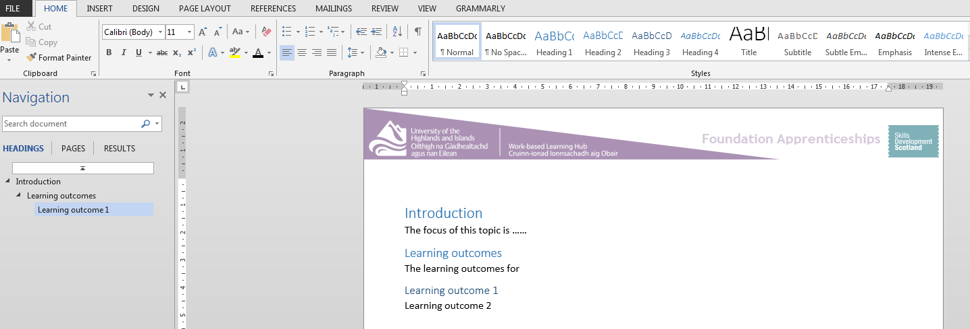

Figure 1 Screen capture of the styles menu showing the navigation panel, three heading styles and normal text

## Creating a table of contents

By using the built-in heading styles you can generate a table of contents which will provide an overview of your learning content and allow students to locate specific learning content easily. The table of contents menu is found on the *References tab.*  To create a table of contents, select *Table of Contents* and choose an option from the dropdown menu. An example of a table of contents is shown in Figure 2.

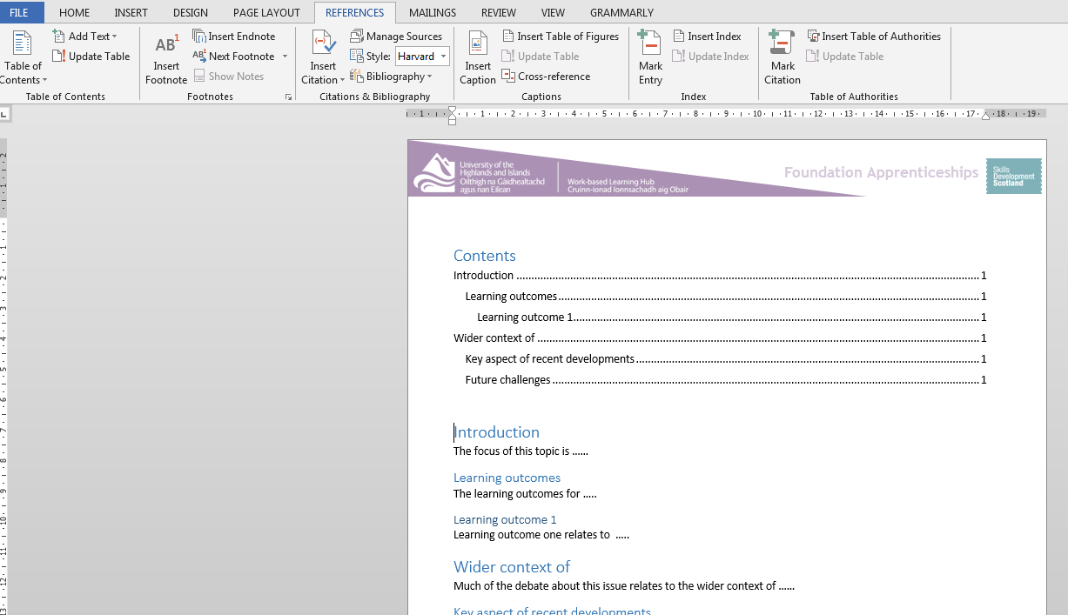

Figure 2 Screen capture showing table of contents based on heading styles

## Adding pictures, screen captures

Pictures and screen captures are useful ways of illustrating and demonstrating learning points. These can be added using the illustrations section in the *Insert* menu. Once you have added the illustration, right-click on it to access a drop down menu. Use the *Insert Caption*, as shown in Figure 3, to add an appropriate title or description of the illustration.

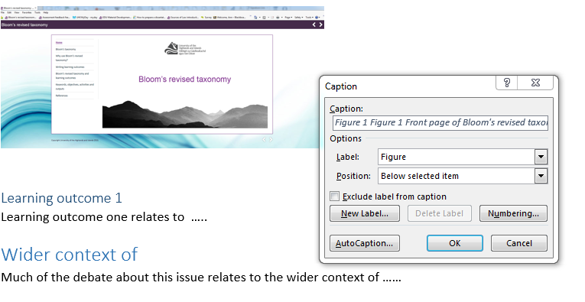

Figure 3 Screen capture showing caption menu

As shown in Figure 4, use the *Format picture option* to add alternative text. Alt Text is read out by screen readers providing information about what is portrayed in the illustration. The Alt Text will also appear when the pointer hovers over an illustration or object in the PDF, once created.

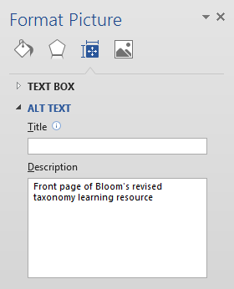

Figure 4 Screen capture of Format Picture Alt Text

The completed illustration will have a caption and alternative text. Using the captions will also allow you to create a *Table of Figures* which provides an overview. Figure 5 shows an example of how this will look.

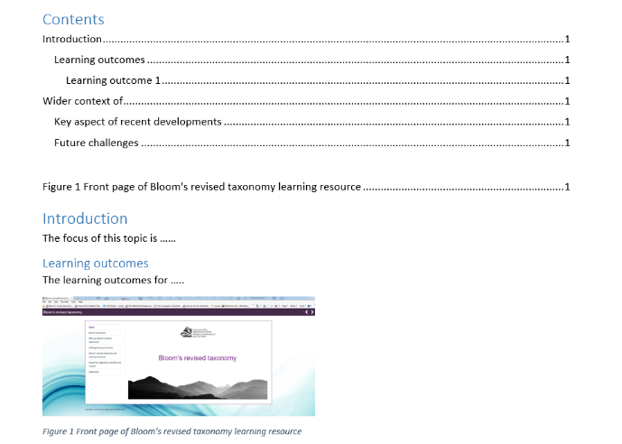

Figure 5 Screen capture of an illustration with caption added to a document and a Table of figures

## Using built-in activity icons

A standard set of activity icons has also been created, in collaboration with the teaching team, as part of the template. These have been developed to support consistent and effective guidance to students, particularly when working through self-directed learning content.

The icons indicate particular types of learning activity. Click on the *Insert tab* and go to the drop down menu within *Quick Parts* – here you will find reusable pieces of content including the set of activity icons created as part of the template. Figure 6 provides an example of how these activity icons can be used in learning content.

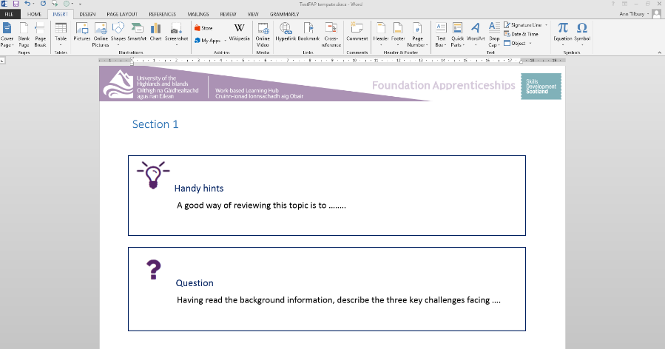

Figure 6 Screen capture of the addition of two activity icons

As the icons appear with an accompanying text description, alternative text has not been added. This is not required as the icon is simply there to provide a visual prompt to the existing text.

# Finding and using images from external sources

Any images you use in your digital learning resources should adhere to copyright guidance and be attributed appropriately. [Finding and using images](http://staffresources.uhi.ac.uk/finding-using-images/index.html) provides an easy to use guide to key aspects of finding and using images without breaking copyright law.

# Preparing and checking prior to exporting to PDF

You can check the accessibility of your document by using the *Accessibility Checker*. This is found in the *File, Info, Check for Issues* menu as shown in Figure 7 below.

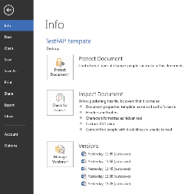

Figure 7 Screen capture showing file info menu

The *Accessibility Checker* inspection results appear on the right-hand side of your document and highlight two key levels of issues - Errors and Warnings. As you fix any errors they will disappear from the list. The Accessibility Checker also includes Why Fix and How to Fix additional information as shown in Figure 8.

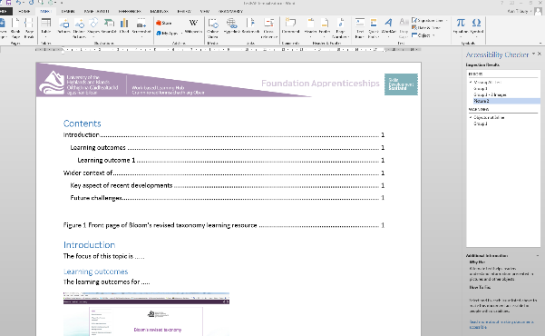

Figure 8 Screen capture showing document and Accessibility Checker

If you have used a number of images you might want to ensure they are compressed. To do this, click on any of the images in the document, select *Compress Pictures* from the *Picture Tools* format menu as shown in Figure 9 below.

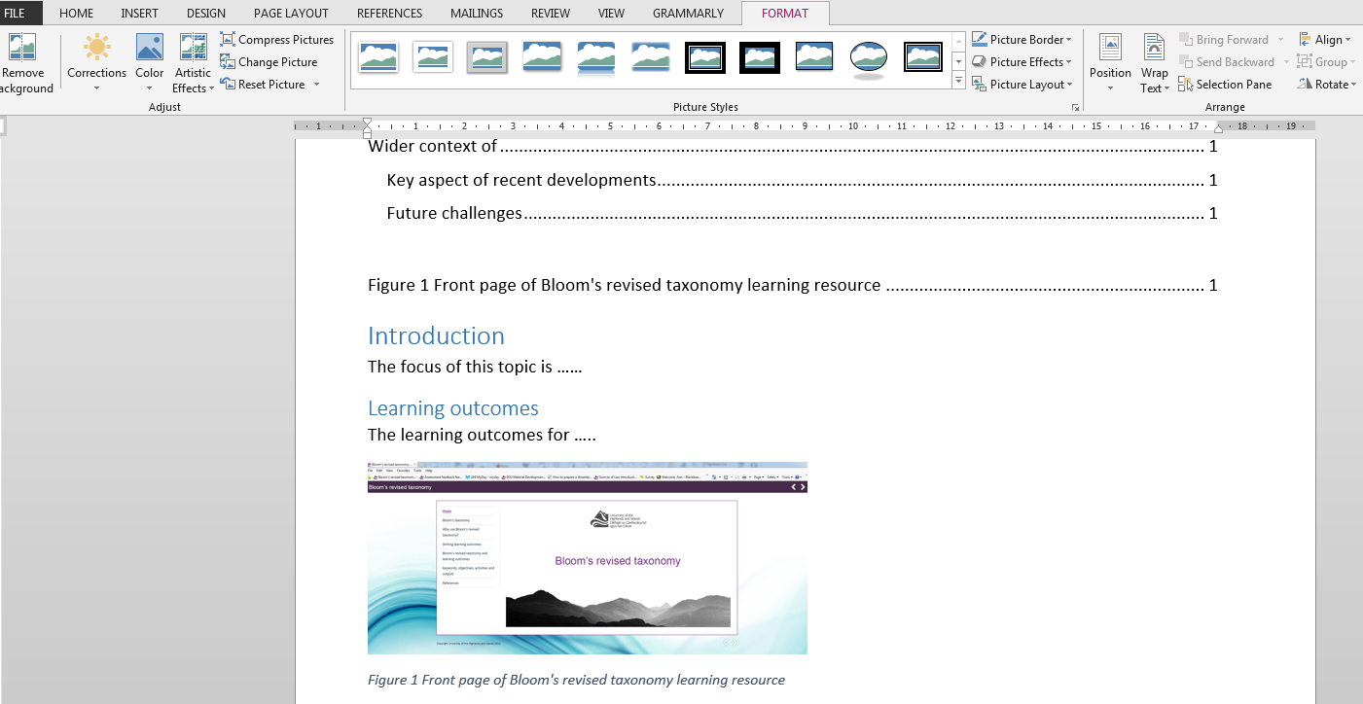

Figure 9 Screen capture showing picture tools, format menu

In the *Compress pictures* menu ensure the *Apply only to this picture* is un-ticked and that the Delete cropped areas of pictures is selected.

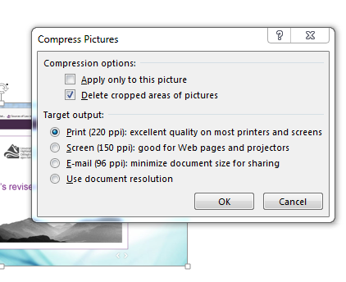

Figure 10 Screen capture showing Compression Picture menu options

# Exporting to PDF

To export a Word document to PDF, select *File and Save as*. From the *Save as type* drop-down menu, select *PDF* as shown in Figure 11 below.

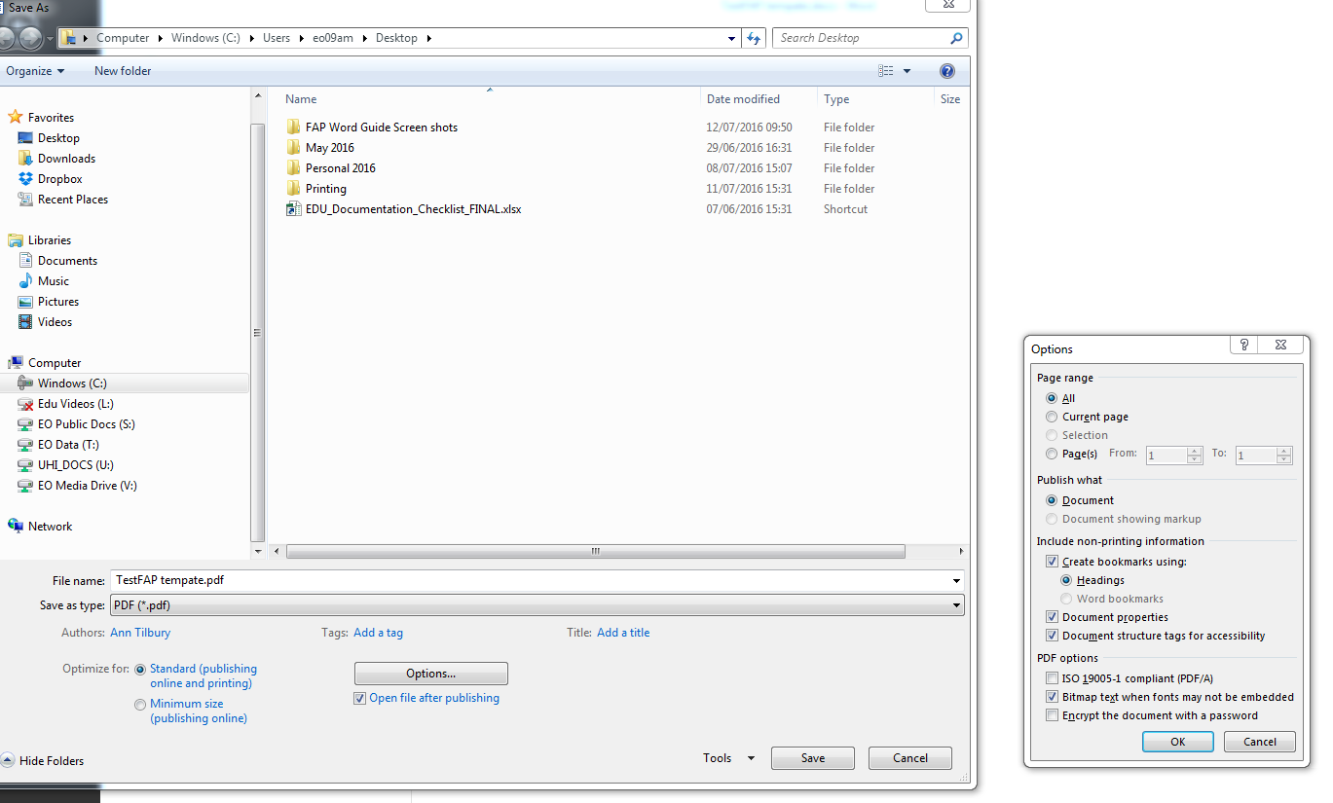

Figure 11 Screen capture showing save as PDF

In the *Options* menu ensure that the *Create bookmarks using Headings* button is selected. Click on *OK* as shown in Figure 12 and then select *Save*. Note that the option to “*Create bookmarks using*…” is only available if heading styles have been used in the Word document.



Figure Screen capture showing menu options for Windows 2013

Windows 2016 provides slightly different options as shown in Figure 13.

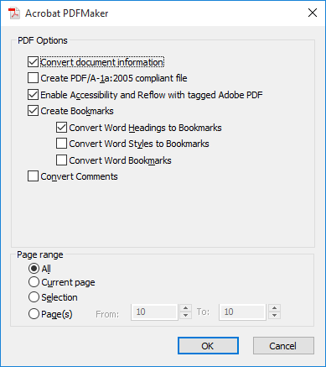

Figure Screen capture showing options in Windows 2016

# PDF document

The PDF document you have created will have a clear navigation menu created as bookmarks. Alt text will also appear when the mouse hovers over images.

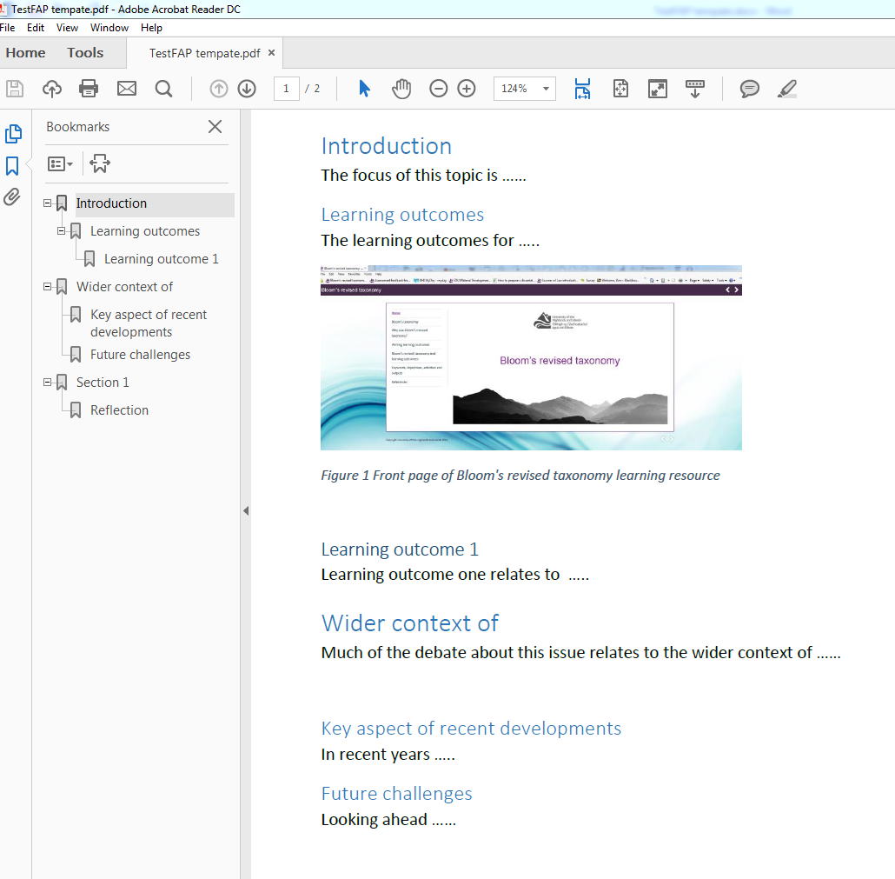

Figure 14 Screen capture showing PDF